* **What is Box Model**The CSS box model is essentially a box that wraps around every HTML element. It consists of: margins, borders, padding, and the actual content. The image below illustrates the box model:

div {

background-color: lightgrey;

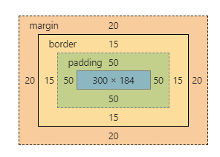

width: 300px;

border: 15px solid green;

padding: 50px;

margin: 20px;

/* box-sizing: border-box; */

}

* Content - The content of the box, where text and images appear
* Padding - Clears an area around the content. The padding is transparent
* Border - A border that goes around the padding and content
* Margin - Clears an area outside the border. The margin is transparent

Total element width = width + left padding + right padding + left border + right border + left margin + right margin

The total height of an element should be calculated like this:

Total element height = height + top padding + bottom padding + top border + bottom border + top margin + bottom margin

**What is Specificity?**

If there are two or more conflicting CSS rules that point to the same element, the browser follows some rules to determine which one is most specific and therefore wins out.

The universal selector (*) has low specificity, while ID selectors are highly specific!

**How to show center of one block element into another block element ?**

**What is shadow dom in css**

**What is position Property**The position property specifies the type of positioning method used for an element (static, relative, fixed, absolute or sticky).

* **Static :** HTML elements are positioned static by default.
* **Relative :** An element with position: relative; is positioned relative to its normal position.but we can set top, bottom, left, right
* **Fixed :** it always stays in the same place even if the page is scrolled. The top, right, bottom, and left properties are used to position the element.
* **Absolute :** An element with position: absolute; is positioned relative to the nearest positioned ancestor (instead of positioned relative to the viewport, like fixed).  
  However; if an absolute positioned element has no positioned ancestors, it uses the document body, and moves along with page scrolling.
* **Sticky :** An element with position: sticky; is positioned based on the user's scroll position.

**visibility hidden and display none :**

display:none means that the tag in question will not appear on the page at all (although you can still interact with it through the dom). There will be no space allocated for it between the other tags. visibility:hidden means that unlike display:none , the tag is not visible, but space is allocated for it on the page.

**What are psudo :: element and psudo : class ?**A pseudo-class is used to define a special state of an element.

Style an element when a user mouses over it

Style visited and unvisited links differently

Style an element when it gets focus  
a:hover {  
  color: #FF00FF;  
}

A CSS pseudo-element is used to style specified parts of an element.

For example, it can be used to:

Style the first letter, or line, of an element

Insert content before, or after, the content of an element  
p::first-line {  
  color: #ff0000;  
  font-variant: small-caps;  
}  
**Diffenreces :**

Basically a **pseudo-class** is a selector that assists in the selection of something that cannot be expressed by a simple selector

**Pseudo-elements** effectively create new elements that are not specified in the markup of the document and can be manipulated much like a regular element

**Data Attributes in css**

<span data-tooltip="A simple explanation">Word</span>

You can use data attributes in CSS to style elements using attribute selectors. You can also show the information stored in the data attribute to users (in a tooltip or some other way) with the help of the attr() function.

span.tooltip::before {

content: attr(data-tooltip);

position: absolute;

top: 1.5em;

font-size: 0.9em;

padding: 1px 5px;

display: none;

color: white;

background: rgba(0, 0, 0, 0.75);

border-radius: 4px;

transition: opacity 0.1s ease-out;

z-index: 99;

text-align: left;

}

**How can I create a given in pure css**

<div class="tri"></div>

.tri{

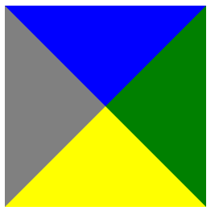

height:0px;

width:0px;

background-color:red;

border-top:100px solid blue;

border-bottom:100px solid yellow;

border-left:100px solid white;

border-right:100px solid green;

}

**How to create given design**

.tri{

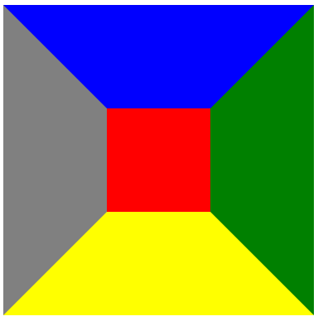

height:100px;

width:100px;

background-color:red;

border-top:100px solid blue;

border-bottom:100px solid yellow;

border-left:100px solid gray;

border-right:100px solid green;

}

How to create triangle

.tri{



width: 0;

height: 0;

border-left: 10px solid transparent;

border-right: 10px solid transparent;

border-bottom: 10px solid black;

}

.tri{

width: 0;



height: 0;

border-left: 10px solid transparent;

border-right: 10px solid transparent;

border-top: 10px solid black;

}